Accessible Travel, a $58 Billion Market, Gets Its First One-Stop Shop
AccessibleGo is the first website to tailor bookings for flight, hotel and car rentals for travelers with special needs. Competition is growing fast.
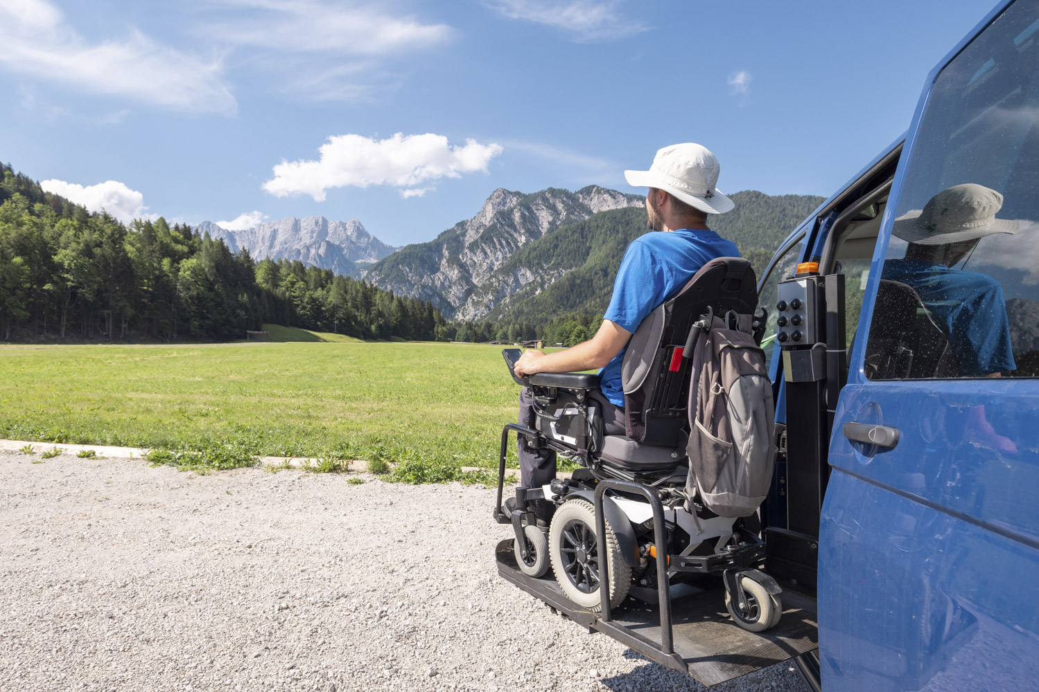
Wheelchair vans, car rentals with special features, hotels and flights can all be booked via accessibleGO’s expanded travel booking site.
Photographer: 24K-Production/Getty Images
By Lily Girma
January 25, 2024 at 6:15 AM EST
Save
Listen
5:13
Before the Covid-19 pandemic, Americans with disabilities made up an active, rapidly growing segment of the travel industry. In 2018 and 2019, at least 70% of them (28 million people) collectively spent $58.7 billion on trips, according to a 2020 nationwide study conducted by the Harris Poll. The report, commissioned by Open Doors Organization, an accessible-travel advocacy group, shows that such spending has skyrocketed—up 339%, from $17.3 billion, in 2015. Still, more than 70% of the special needs travelers reported that they encountered major obstacles in dealing with airlines, airports, cruise lines and hotels.
Accessible travel took a hit during the pandemic years, like every other travel segment. And now, with travel spending soaring, a startup focused on accessible vacations aims to better serve the sector.
On Jan. 17, hotel-focused booking platform accessibleGO announced a wide-reaching expansion to make it simpler for travelers with disabilities to plan trips. Having helped them find rooms with up to seven special accessibility features in 180 destinations across the US since 2018, the platform is moving to address nearly every facet of a vacation, from flights to airport transfers and car rentals.
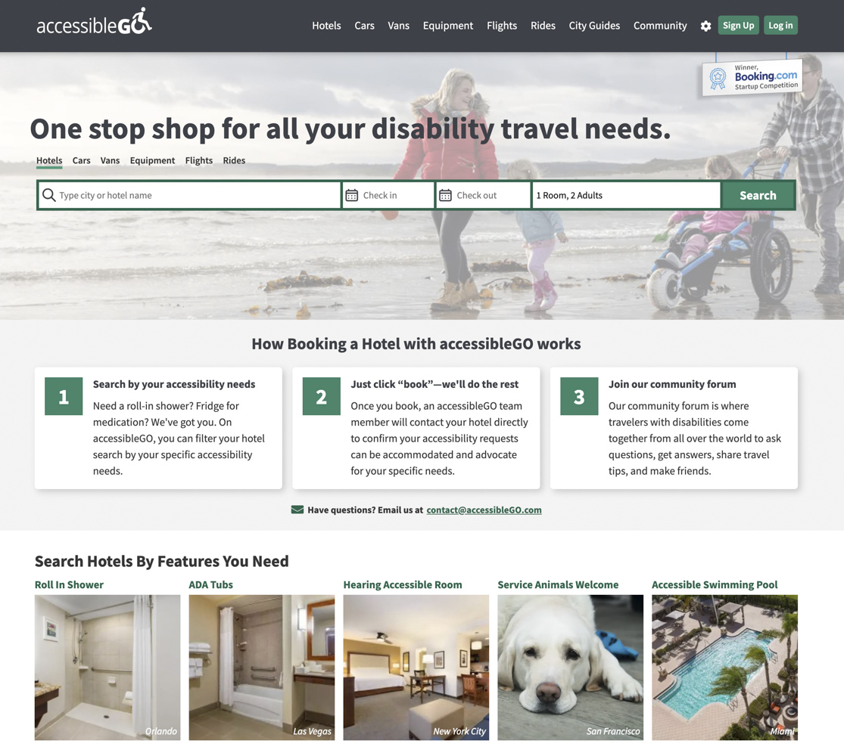
AccessibleGo is offering a one-stop booking site for US travelers with disabilities.Source: accessibleGO
“There was very limited interest in our demographic when we started [in 2018],” says Miriam Eljas, accessibleGO’s co-founder and chief executive officer, who was inspired to create the site after traveling with her late mother, who had multiple sclerosis. “Now, it's really changed. There's been this awakening in the travel industry that there is this market—and they want to travel and they have these needs that must be met.” To wit, Eljas says, accessibleGO’s booking volume was four times higher in 2023 than in 2022.
For a special needs traveler, booking a vacation can be far from seamless. It’s not always guaranteed, for instance, that a traveler in a wheelchair will receive prompt service at an airport, whether they’re traveling with a service animal or need assistance to get from the check-in counter to the gate. Even if they obtain the requested room with a roll-in shower or a fridge to store medicine, they might find accessibility features to be insufficient in the same hotel’s lobby and restaurants. And when it comes to transportation around their destination, a rental car might lack the necessary add-on features, while public transit might be short on wheelchair-accessible options.
As the first one-stop shop for accessible travel in the US, accessibleGo is addressing all of this. Book a flight on its site, for instance, and you can add specific special needs requests. A new rental car portal has options from all the major companies, including wheelchair vans and such optional accessibility features as spinner knobs that make it easier to steer with one hand. Users can book wheelchair-accessible taxi services and rent mobility accessories and hotel aids like scooters, wheelchairs and hoyer lifts, which help them shift from bed to wheelchair and vice versa.
Part of what complicates the expansion is a continued need for “white glove service,” as Eljas describes it, to ameliorate (if not quite eliminate) blunders by airlines and other providers. While the Americans with Disabilities Act and Air Carrier Access Act legally require buildings and airlines in the US to accommodate wheelchair users in specific and detailed ways, it can be onerous to confirm that they will meet the moment; this usually requires lengthy discussions with customer service. AccessibleGo is taking on that responsibility for every hotel, flight and car rental booking made on its platform. “It's a core part [of our proposition] that makes people trust us and understand we've got their back,” says Eljas. “And that's a very big part of [working with] this demographic—making them feel confident and safe.”
Eric Lipp, founder and executive director at Open Doors Organization, says this service is accessibleGo’s biggest competitive advantage. “A lot of times information doesn't get conveyed from a third-party vendor [such as Booking.com or Expedia] to the carrier, cruise line or hotel,” he explains.
Travelers with disabilities make up a $58.7 billion market, according to Open Doors Organization.Photographer: 24K-Production/Getty Images
AccessibleGo is not alone in trying to address this large but overlooked market. Competition now includes Wheel the World, which offers hotels, activities and group tours in 117 global destinations, and Responsible Travel, a marketplace for multiday tours whose website includes a filter for accessible itineraries around the world. Such services are growing at pace with accessible advocacy: Groups like the International Air Transport Association, International Civil Aviation Organization and Airlines for America are all discussing accessibility with greater urgency.
AccessibleGo thus faces challenges to dominate the market. It must grow quickly to serve international destinations and to add activities and tours before competitors catch up on the airline and car rental fronts. The company is scaling-up its reach by partnering with Arc, a nonprofit organization with 800 nationwide chapters for people with developmental disabilities. In exchange for marketing access to Arc’s sizable user base, accessibleGo is creating a give-back program to support the nonprofit. It hopes to replicate this model with other nonprofits in the near future.
Meanwhile, with Open Doors’ next national study already underway, the market for accessible travel seems certain to keep growing.
“I can tell you—just looking at the number of wheelchair pushers [who help disabled travelers] at airports,” says Lipp. “We are out in pretty full force.”
https://www.bloomberg.com/news/articles/2024-01-25/the-best-websites-for-booking-accessible-travel-in-the-us-and-beyond

