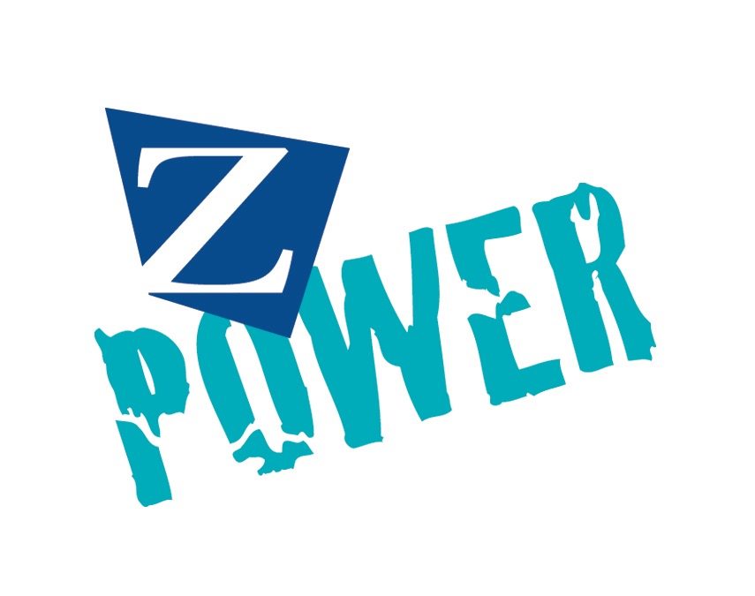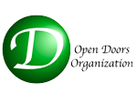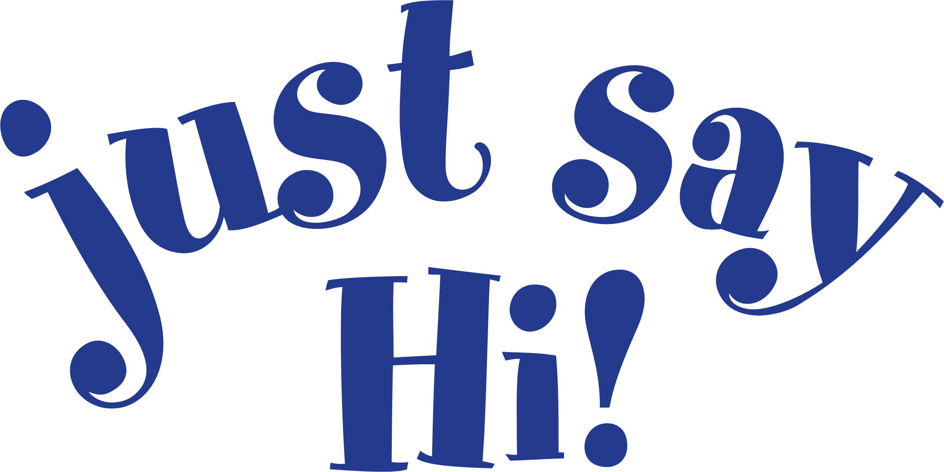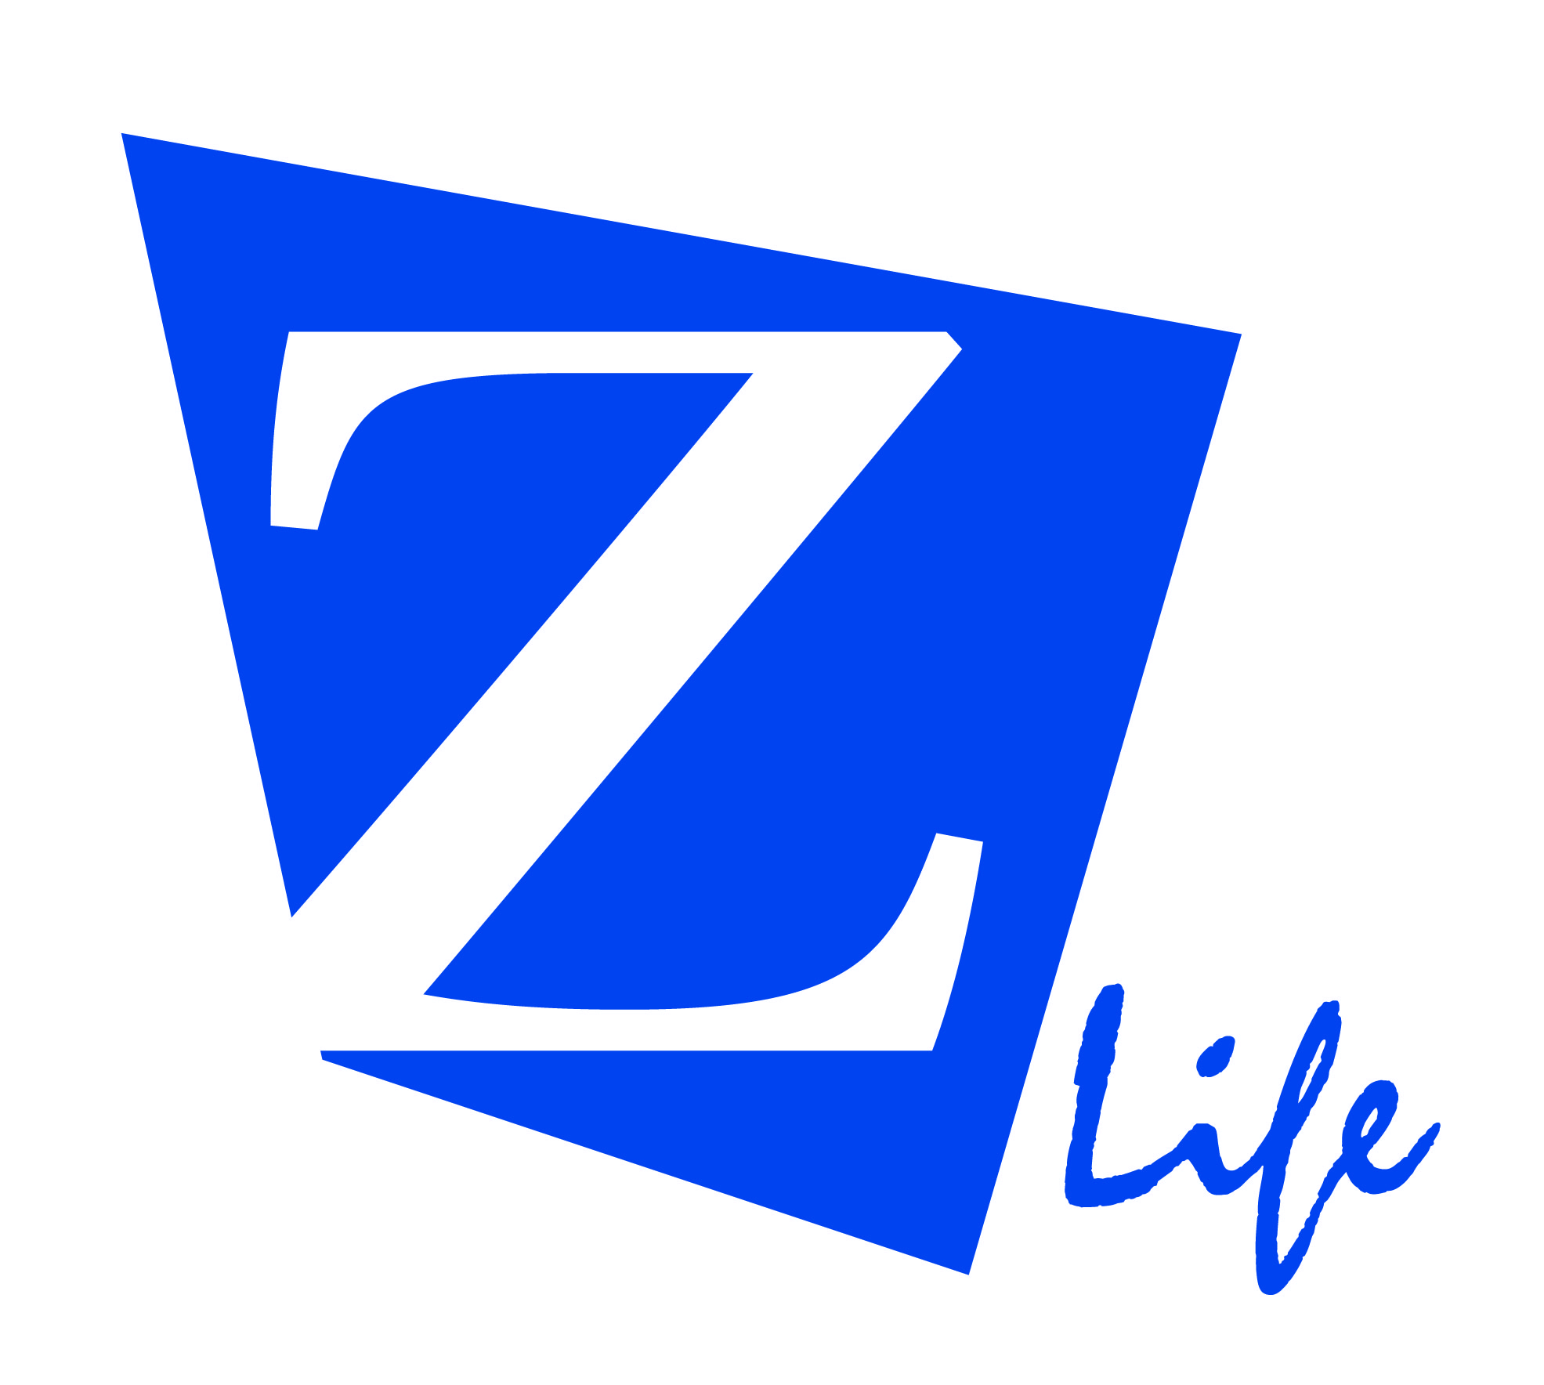

RIO 2016 Torch Relay

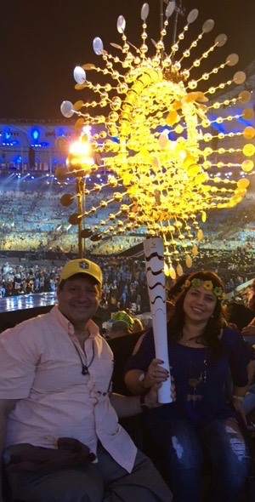

ATHENS 2004 Torch Relay

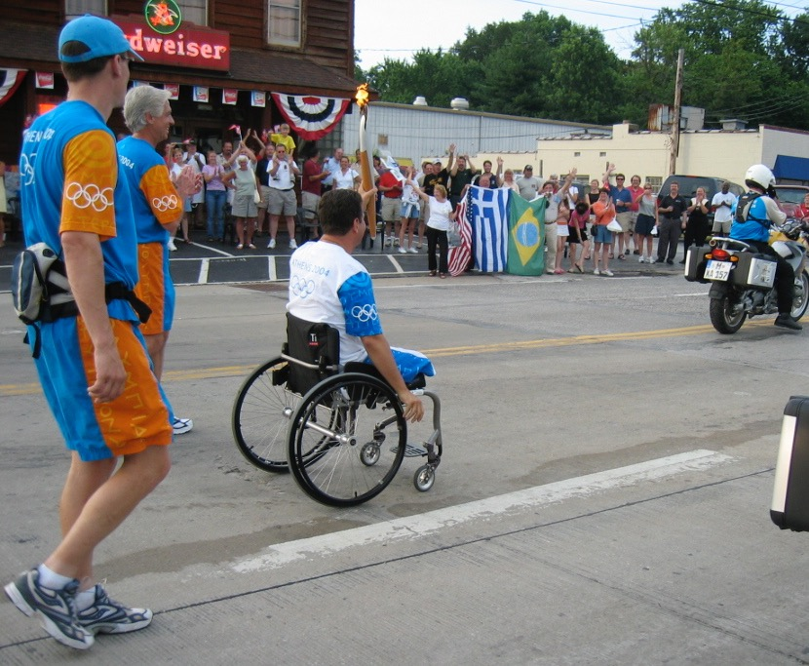

**“**Z**”**

From a Greek word meaning “live”

“Power”

Ability to do or act; capability of doing or accomplishing something

The POWER for you   
to do the best YOU CAN  
with what YOU HAVE!

Information...   
 Integration...   
 Participation...  
 Among people with disabilities

Constantine Zografopoulos

Program Director

Open Doors Organization

Z Life Program

10600 W. Higgins, Suite 609

Chicago, IL 60018

Tel: 773-388-8839

Cell: 773-230-1247

Email: constantine@opendoorsnfp.org

Website: opendoorsnfp.org

Tel: 773-388-8839  
Cell: 773-230-1247

Email: constantine@opendoorsnfp.org

Website: opendoorsnfp.org

When meeting someone,  
with or without a disability,  
remember to share your smile   
and...

TM

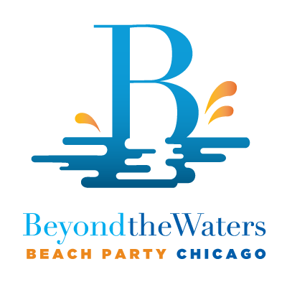

# Regional/Citywide Programs

* Open Doors Organization - Disability Business Resource Center - Training and Seminars
* Chicagoland Alliance for Disabled Owned Businesses
* “Just Say Hi!” Awareness Program
* Chicago Disability Pride Parade
* Shirley Ryan AbilityLab - Peer Visitor Program - Adaptive Recreational Sports
* Chicago Park District - Beach Walk Access
* Greek Orthodox Metropolis Chicago - TEAM Belong Program & GLOH
* Chicago No Limits Fishing Program
* Annual Beyond the Waters Beach Party

# International Programs

* PERPATO Organization, Greece
* Greek Orthodox National Ladies Philoptochos Society - Wheelchair Project 2007
* ANDEF, Rio de Janeiro, Brazil

Beyond the Water Beach Party Chicago - Beach Walk

Easy Access Chicago Guide

www.easyaccesschicago.org

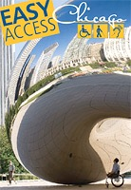

Z LIfe is a program of Open Doors Organization, a 501 (c)(3) non-profit organization in Illinois

The mission is to provide and create **information, integration and participation** among people with disabilities and their families and friends through fun events

* Provide hope and help individuals find their strength and confidence
* Believe that everyone has the ability to face the challenges of life
* Encourage greater accessibility and universal design worldwide
* “Just Say Hi!” slogan to create and promote public awareness of individuals with disabilities. To approach and treat everyone the same, without discrimination

COMMUNITY

OUTREACH

PROGRAMS

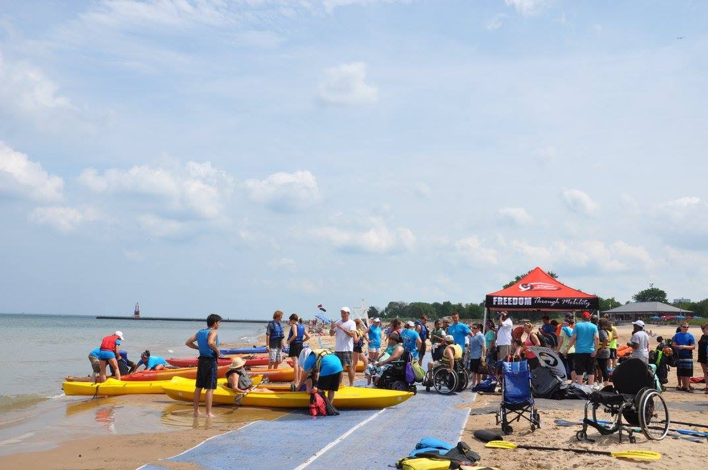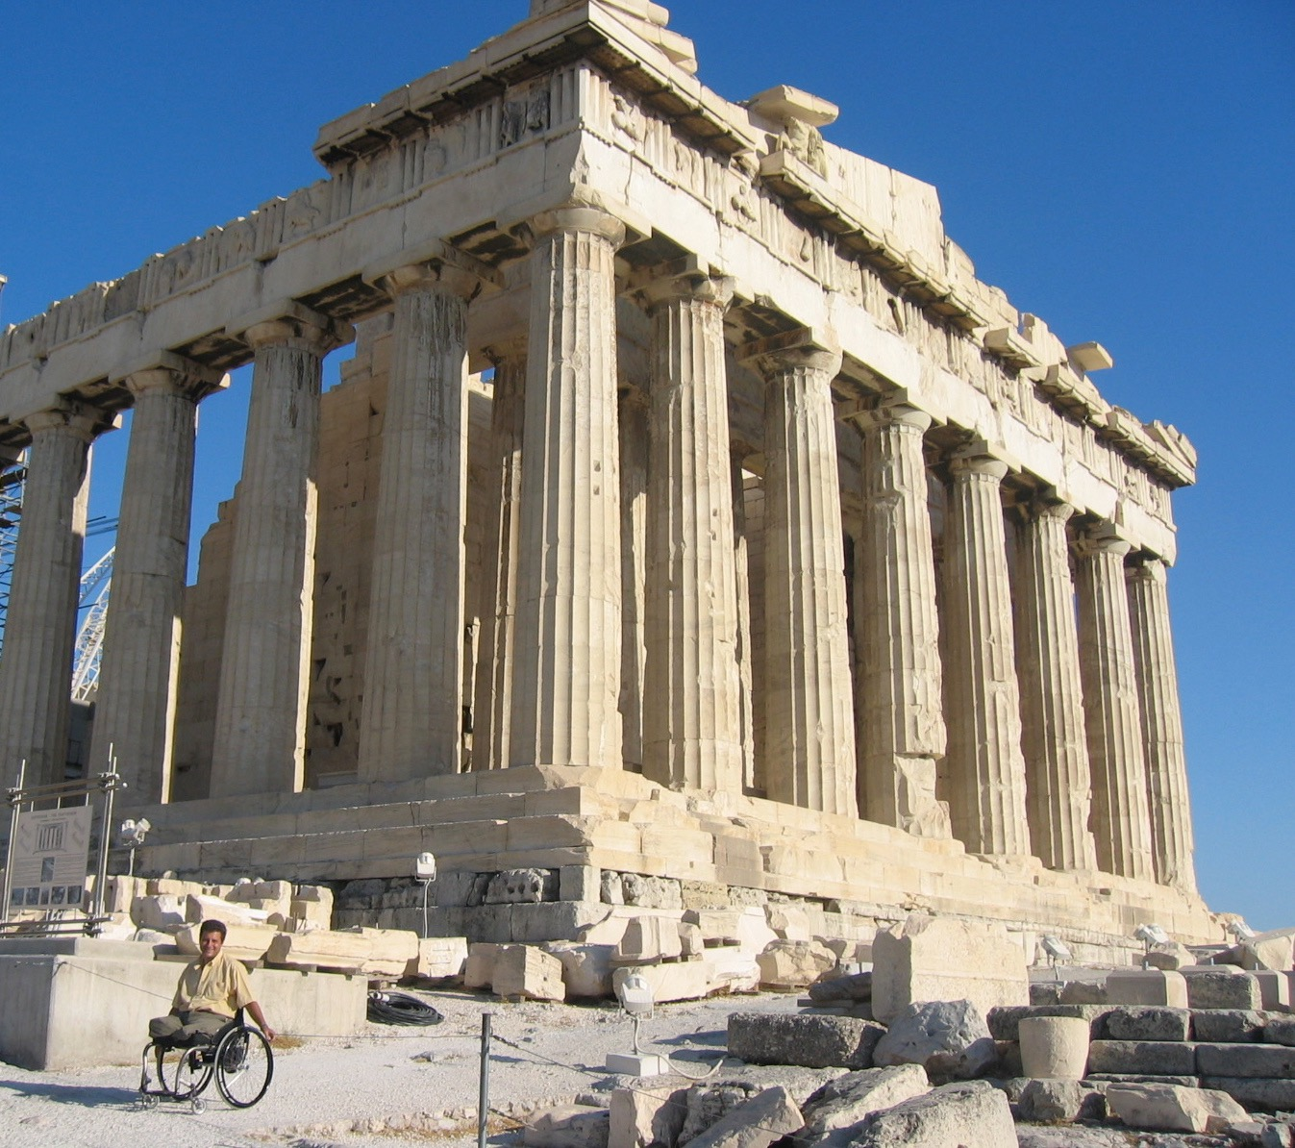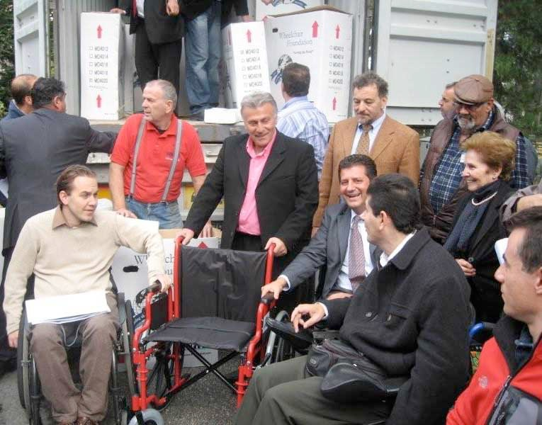

Wheelchair Distribution in Greece

Acropolis Now Accessible